1.Consider the following schedule of Transactions T1T2,T3.What would be the correct serialization of the given schedule.Explain why it is so.

[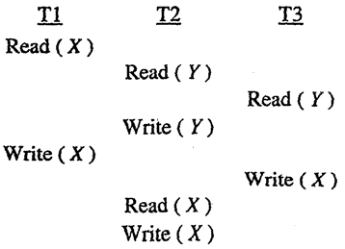](http://www.geeksforgeeks.org/wp-content/uploads/gq/2013/12/GATE2010DBMS1.png)

1b. Check whether the given schedule is view serializable or not.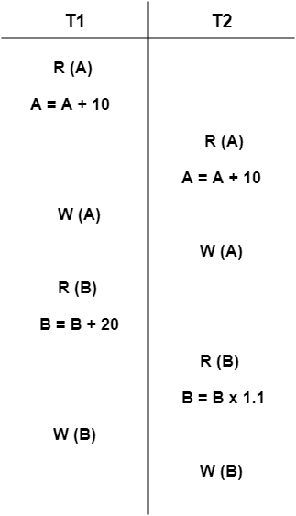

2. Consider a simple checkpointing protocol and the following set of operations in the log.

(start, T4); (write, T4, y, 2, 3); (start, T1); (commit, T4); (write, T1, z, 5,7);

(start, T2); (write, T2, x, 1, 9); (commit, T2); (start, T3); (write, T3, z, 7, 2);

If a crash happens now explain how does the system recover.

3. Consider the following database schedule with two transactions, T1 and T2.

S= **r2(X); r1(X); r2(Y); w1(X); r1(Y); w2(X); a1; a2;**

where ri(Z) denotes a read operation by transaction Ti on a variable Z, wi(Z) denotes a write operation by Ti on a variable Z and ai denotes an abort by transaction Ti .Explain whether the schedule is recoverable,non-recoverable?

4. a) The keys 12, 18, 13, 2, 3, 23, 5 and 15 are inserted into an initially empty hash table of length 10 using open addressing with hash function h(k) = k mod 10.. What is the resultant hash table?

b) Distinguish between ordered and unordered files?

5. Consider a disk with block size B = 512 bytes. A block pointer is P = 8 bytes long, and a record pointer is Pr = 9 bytes long. A file has r = 50,000 STUDENT records of fixed-size R = 147 bytes. In the file, the key field is ID#, whose length V = 12 bytes. Answer the following questions:

1. If an unspanned organisation is used, what are the blocking factor bfr and the number of file blocks b?
2. Suppose that the file is ordered by the key field ID# and we want to construct a primary index on ID#. Calculate the index blocking factor bfri.
3. What are the number of first-level index entries and the number of first-level index blocks?
4. Determine the number of block accesses needed to search for and retrieve a record from the file using the primary index, if the indexing field value is given